
Presented to:
Mrs. Natasha EL Bitar
Prepared by:
Ghadeer Khalaf
22230345
School Of Arts and Sciences
Computer Science Department

CSCI380 – Software Engineering
TRAVEL PLANNER

TEXT:
The project aims to develop a mobile application for trip planning, integrating advanced technologies and APIs to provide users with comprehensive information on destinations, flights, accommodations, and activities. Key features include real-time access to travel data and weather forecasts, itinerary management, budget tracking, and social sharing capabilities. The platform aims to revolutionize trip planning by offering a seamless and stress-free experience for travelers worldwide.

FUNCTIONAL REQUIRMENT:
1.User Registration: Users should be able to create accounts to access the full functionality of the application.
2.Destination Search: Allow users to search for destinations based on criteria such as location, interests, and travel dates.
3. Flight Booking: Enable users to search for and book flights using integrated APIs from airline providers.
4. Accommodation Booking: Provide users with the ability to search for and book accommodations, including hotels, vacation rentals, and hostels.
5. Activity Recommendations: Offer suggestions for activities and attractions at each destination based on user preferences and interests.
6. Itinerary Creation: Allow users to create personalized trip itineraries, including adding activities, scheduling events, and setting reminders.
7. Real-time Weather Updates: Integrate weather APIs to provide users with up-to-date weather forecasts for their destination.
8. Budget Setting: Enable users to set a budget for their trip and track expenses throughout the planning process.
9. Expense Tracking: Provide tools for users to track expenses related to flights, accommodations, activities, and other travel-related costs.
10. Social Sharing: Allow users to share their trip plans, experiences, and photos on social media platforms directly from the application.

11. Review and Rating System: Implement a system for users to leave reviews and ratings for destinations, accommodations, and activities.

NON FUNCTIONAL REQUIRMENT:
- Performance: Ensure fast loading times and smooth navigation, even during peak usage periods.
2. Scalability: Design the application architecture to accommodate a growing user base and increased data volume over time.
3. Reliability: Minimize system downtime and ensure high availability of services to prevent disruptions to users’ trip planning activities.
4. Security: Implement robust security measures to protect user data, including encryption of sensitive information and adherence to data protection regulations.
5. Usability: Prioritize intuitive design and user-friendly interfaces to enhance the overall user experience and encourage engagement with the application.

USE CASE DIAGRAM:
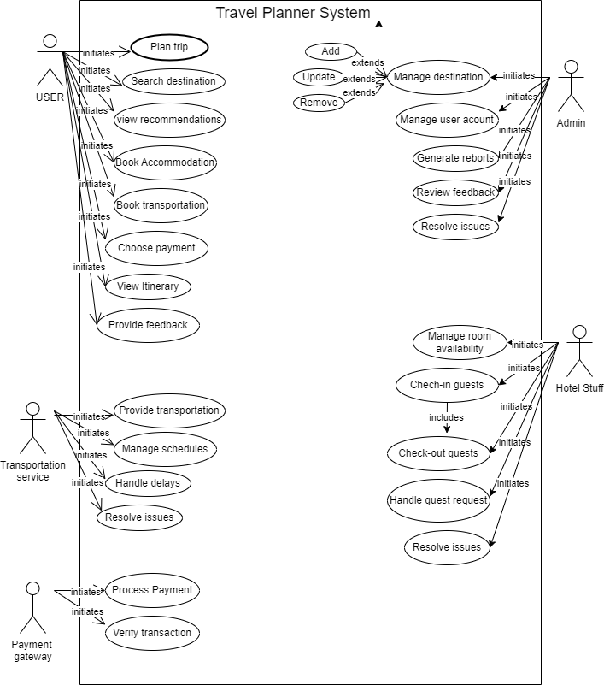

USE CASE NARRATIVE:

Use case-Name: | Search Destination
Use case-ID: | MCS-003
Priority: | High
Primary actor: | User
Description: | The Search Destination use case allows users to search for destinations based on various criteria such as location, interests, and travel dates. This is a high-priority use case as it serves as the initial step in trip planning, providing users with essential information to make informed decisions about their travel itinerary.
Precondition: | - The user has successfully logged into the Travel planner application.  - The user has access to an internet connection to perform the search.
Typical course of  Events: | Actor Action: | System response:
Typical course of  Events: | 1.User opens the Travel Planner application and navigates to the search feature  2. User enters criteria such as destination location, interests, and travel dates into the search fields.  3. User submits the search query. | 1. The application processes the search query and sends requests to integrated APIs for travel data.  2. Relevant destination information is retrieved from the APIs based on the user’s criteria.  3. The application presents the search results to the user, including destination descriptions, attractions, activities, and accommodation options.
Conclusion: | - User reviews the search results to assess destinations that match their preferences and travel needs.
Post-condition: | - The user has successfully searched for destinations meeting their specified criteria.  - The user can proceed to explore further details about the selected destination or refine their search if necessary.

ER-DIAGRAM:

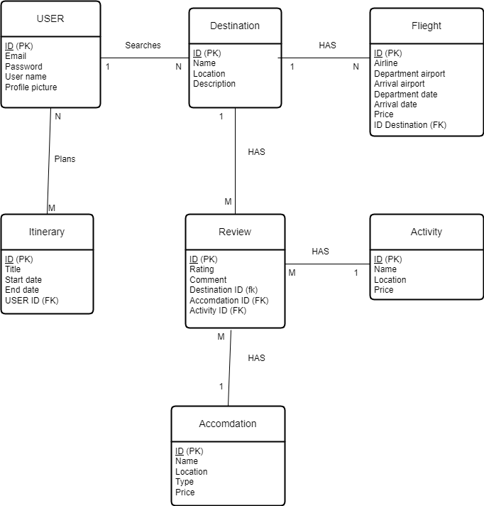

DATA FLOW-DIAGRAM:
LEVEL 0:

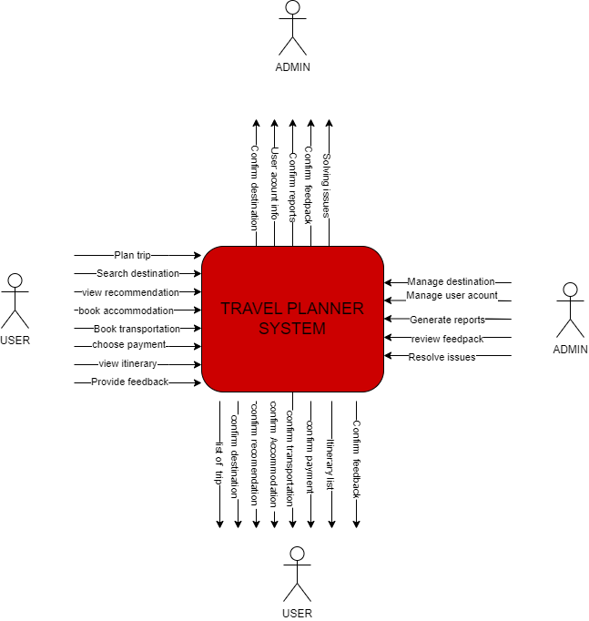

LEVEL 1:



